**Bramcote Community Action Team Minutes**

**6th March 2024**

**Held at Bramcote Memorial Hall**

## Present:

| Name | Organisation | Initials | Contact details |
| --- | --- | --- | --- |
| Cllr Hannah Land | Broxtowe BC | HL | [hannah.land@broxtowe.gov.uk](mailto:hannah.land@broxtowe.gov.uk) |
| Cllr Andy Kingdon | Broxtowe BC | AK | andrew.kingdon@broxtowe.gov.uk |
| Cllr Steve Carr | Nottingham CC | SC | steve.carr@broxtowe.gov.uk |
|  |  |  |  |

Around 40 residents attended.

## 1. Welcome and Introductions

Cllr Kingdon welcomed everybody to the meeting and introduced the panel. Broxtowe Liberal Democrats Parliamentary candidate James Collis was introduced to the meeting.

## 2. Apologies

Cllr David Watts – attending to family matters. No response from County Councillors John Doddy or John Macgrath.

## Minutes and Updates on actions from last meeting

Minutes approved. See matters arising for actions and updates

# Matters Arising

Japanese knot weed on land near Sandy Lane – Update via DW, council have written to landowners advising they need to take action or legal action may follow. Residents questioning if the council is certain that the JKW has not spread to the council owned land.

Action – SC will seek clarity from Council and circulate response when received.

(Please see that response pasted at the end of these minutes)

Balloon Woods Junction (Coventry Lane) – Road condition exceedingly poor. SC reports County admit responsibility and has been identified for repairs in 2024-25. SC will monitor. Disappointing that highways agency have let it get in such a state. Boundary commission maps are very clear about city and county boundary.

Moor Lane – Planned patch repairs up to number 86. County have also agreed to repair potholes on Bridal Way but will not adopt it.

Quarry Works (Chilwell) – BBC undertaking repairs to Quarry wall, loan of £1 million.

Action – Find out if alternative options have been considered.

Bramcote School – land still awaiting transfer to developers, County claiming there is too much surplus which school will need to pay back more money to county. County refusing to use funds for new leisure centre. Resident highlighted that the Academy Trust have always been clear that surplus would be transferred back to county council. Disappointing that the money won’t be used for the benefit of Bramcote.

# Borough Council Update

Budget approval in process. Minimal rises to council tax, labour administration are increasing fee for parking, garden waste collection etc

Fishpond Cottage - cabinet approved the original development plans for 5 properties. Bramcote and Beeston North Councillors called the decision in for scrutiny. Referred back to Cabinet – will be reviewed at the meeting next week. Labour run cabinet will likely approve the plans. The labour group have a determination to build affordable houses at speed with little thought to the quality.

Bramcote Leisure Centre – cross party working group has been established and will meet soon to look at the design of the new leisure centre with a view to submitting a planning application. Cabinet agreed funding for the planning application and design.

Actions – Cllrs to ensure public consultation occurs. Residents to submit comments to Cllrs HL and SC.

Car parking fees – increased in January. Residents feel this will not encourage footfall in town centres.

# County Council Update

Budget approved – maximum increase in council tax set. Band D property will increase to over £2000 per year. Independent group tabled an amendment for the county council to sell the land at Toton and use the money for road repairs. Defeated by the Tory administration. The land at Toton is of little use since HS2 has been shelved.

Parking issues – plans for restrictions on Moor Lane. Also plans for double yellow lines on Cow Lane opposite school entrance.

SC also wants to set up a speed watch initiative in Bramcote. Suggested roads – Ilkeston Road, Coventry Lane, Town Street, **?????**

Action – Liaise with SC if interested in volunteering and other suggestions.

Pot Holes – Cllrs report, residents need to report using the website, phone line or my notts app. County council had new machine for repairs in 2019. Has been used once in Broxtowe. Send complaints to chief exec of county council and can escalate to ombudsman if not satisfied with response.

# Planning Matters

Battery storage application has been appealed to the planning inspector – send comments to planning inspector. All previous comments on the portal will be considered by the inspector.

There is a second application on the same site which was launched on the portal. The neighbourhood forum are creating a response and have sent a response to the inspector. They feel the exceptional circumstances for developing the greenbelt have not been met. The facility is not of benefit to Bramcote, there are already 120 applications of this sort coming to the East Midlands which far exceed the size and capacity of this proposal. Nationally there are 5 times the amount national grid require planned. Those applications are more certain to be delivered too. The facility does not meet the national grid standards. Also given the sheer number of these projects in the pipeline, it is not financially viable.

Other residents have concerns about the fire and flood risks for the A52 which already floods.

Actions - SC will ensure the fire authority and flood authority assess and report thoroughly on the application. Residents and councilors to submit comments on the planning portal. Individual responses are as important as the councilors and BNF.

1. **Police – No update.**
2. **Neighbourhood Forum**

Paul Nathanial updated the meeting. Awaiting approval of neighbourhood plan from Council. Has progressed since last meeting.

Linking with Toton and Chetwynd Neighbourhood forum as their plan has been approved by the council. Concerns remain about the proposed access road – opposed by Bramcote NF.

See response to battery storage application.

Residents can join the Bramcote NF using this link here <https://bramcoteneighbourhoodforum.org.uk/contact/>

1. **Residents Issues**

Bramcote Golf Course Site – heavy activity on site by Thorsbury Road. Brambles also overgrown onto footpath.

Action – AK to liaise with council.

Moor Lane Hedgerow – consideration of obtaining protection order for hedge row to protect during construction work.

Action – SC and AK to liaise with council.

Thoresby Road junction – witnessing drivers U-turning at the junction – Illegal manoeuvre.

Action – SC to report to Police and highways. Residents should also report to the police.

Foxwood School – now joined the White Hills Park Foundation. No update on new school at Bramcote Park site.

Action – SC to enquire.

Leisure centre / Foxwood and Bramcote Park access road from A52– consideration to allowing right turn exit. Unlikely to get highways approval.

Town Street exit – multiple accidents. Mirror required at junction. Roundabout is already at over capacity without additional housing developments in the area.

Action – Cllrs to liaise with highways.

Speeding – Coventry Lane. Advised once new housing developments are live, speed limit will be reduced to 40. In the meanwhile, consider speedwatch activity there.

1. **Any Other Business**

Bramcote Charities – Suggestion of using monies towards toilet and café facilities in Bramcote park. Other ideas for use are welcome. Contact Cllrs AK, HL or DW. We will approach uniform organisations too.

1. **Dates of Future Meetings**

3rd June 2024

2nd September 2024

2nd December 2024

**Meeting finished at 09:00**

## Note on Japanese Knotweed provided by Broxtowe BC after the meeting

At the Community Action meeting on 4th March, I was asked to find out the current situation with regards to Japanese Knotweed in the local area. I had this reply from Broxtowe BC.

A number of years ago a substantial patch of Knotweed was found growing on Broxtowe owned public open space off Heather Rise, in Beeston North. (green highlight on plan below). This has been treated with stem injection and has now dwindled to a few small canes. It is anticipated it will be completely eradicated by 2025.

A large patch is also present on privately owned land on the north side of the ridge, within Nottingham City boundary. This patch has been identified in a number of planning applications, but no treatment has yet taken place

On Monday 29 January 2024, a site visit was undertaken to check and confirm Knotweed locations on Bramcote Ridge. No new locations were noted on Broxtowe Borough Council open space.

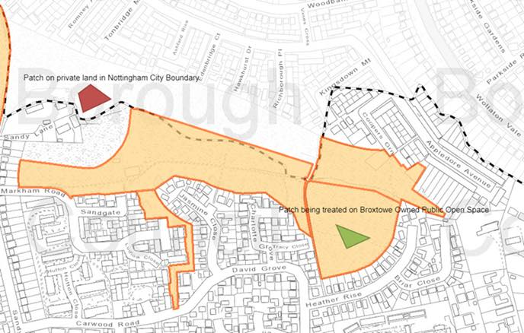

**If you have any issues regarding the minutes or if you require them in large print or in audio format please contact 0115 917 3492 Broxtowe Borough Council,**

**These minutes can be downloaded at** [**www.broxtowepartnership.org.uk**](http://www.broxtowepartnership.org.uk/)

